Nar Valley
Ornithological
Society
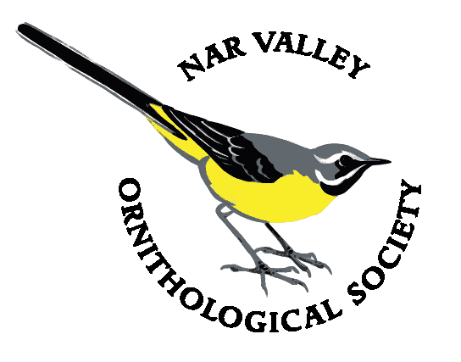

Data Protection Policy

Introduction
The Data Protection Policy describes how members’ data is held and used by the Nar Valley Ornithological Society (NarVOS). The policy has been agreed by the NarVOS Committee and forms part of the Society’s compliance with the General Data Protection Regulation (GDPR).

Personal Data Held
In order to provide our full range of membership services, NarVOS holds all or part of the following personal information on a computer:
- Member’s name
- Member’s address
- Member’s email address
- Member’s home and/or mobile phone number. (Optional but kept if provided)
- Date of subscription payment
- Amount of subscription received
- Free-form comments about the subscription (e.g. if several years’ subscription has been paid in advance)

Uses of Personal Data
The primary purpose of holding this data is for NarVOS to fulfil its obligation to send members’ correspondence, including newsletters to the addresses supplied.
Occasionally, other communications regarding NarVOS business may be sent electronically, by text or by post. In these cases, the communication will only concern the proper functioning of NarVOS activities. Examples might be: subscription change, reminder notices or notices of special NarVOS events.
NarVOS will not use its membership list to supply third parties with address lists or other information unless required to do so under UK law. Nor will NarVOS use the data for fund-raising or direct marketing.

Storage of Membership Data
The membership data is held on a spreadsheet on the NarVOS computer. The computer is password protected and the data is further protected by a separate password. The computer is held by a designated member of the NarVOS Committee. Anti-virus protection is installed on the computer and is updated regularly.
A back-up copy will be made periodically by sending the spreadsheet to a nominated Committee member via encrypted email or a password-protected file or other media. Access to that data is available only to the back-up copy holder. The back-up data will be used only to restore corrupted or lost primary data or for the maintenance of the Newsletter distribution list.
In order to enable query handling, the year-end membership details are held on a separate spreadsheet for two years. Thereafter all data is deleted, and a note made of that fact.

Access to the Data
Only the nominated manager of the data “Data Manager” (normally the Membership Secretary) and the back-up copy holder may access the data and then only for official NarVOS business. If the Data Manager is indisposed the Chairman of NarVOS may appoint another Committee Member to take on that role. If this happens it will be documented.
Members may request in writing access to their own details for their own purposes. Proof of identity will be required before passing this information on. (For example, if a request is received the email address or postal address must match those we hold).

Changes to the Data
Members can request changes such as address or telephone number. Changes will need to be in writing and must include proof of identity such as providing the old address or by sending from the email address we hold.

Deletion of Data
When membership has lapsed, the details of the member will be retained for two years and then deleted. This is to allow time for subscribers who have forgotten to renew to catch up.
If a member resigns then their details will be removed within one month of receipt of resignation.

Declaration
NarVOS is unable to send members any information about our work, meetings, events and activities unless said member has completed a Data Protection Form which is part of the Membership Application Form. By renewing your NarVOS membership you are agreeing that the Society may continue to use your personal data as per your original data protection declaration. (If you do wish to amend your preferences please use the membership form).

